

## Topic: Opening Documents from Hyperlinks

Most, if not all documents in theSource, contain hyperlinks to other related documents. Hyperlinks provide quick and efficient access to information housed in multiple documents.

Also, some documents in theSource are ‘non-searchable’, meaning they cannot be accessed by performing a search in theSource simply using the Content ID or title. Rather, they can only be opened from hyperlinks located within other documents. These often include things like forms, samples, templates, and reference documents, which may be less effective as ‘standalone’ documents.

* To open a document in a new tab, **simply left-click the hyperlink**. The title of the document will display at the top of the tab so you can quickly identify each document.

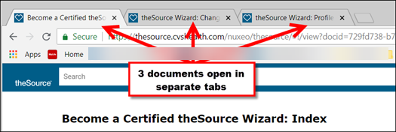

* If you prefer to have your documents open in separate windows, right-click the hyperlink and select: Open link in new window.

**Bonus!** Both documents (the original and the one accessed via the hyperlink) can remain open at the same time, allowing you to toggle from one to the other to access necessary information, as needed.

**Note:** If you click on a hyperlink and it doesn’t open in a new tab (it replaces the current document you are viewing), try using the right-click option to open in a new tab or window. Also, submit feedback on the document and tell us about the hyperlink not opening in a new tab.

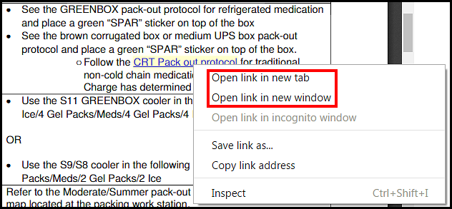

 Your next challenge on the quest to becoming a Certified theSource Wizard is to quickly access multiple documents by using the hyperlinks within other documents in theSource.

Additional resources:

* Become a Certified theSource Wizard: Index.

Not to Be Reproduced or Disclosed to Others without Prior Written Approval

**ELECTRONIC DATA = OFFICIAL VERSION / PAPER COPY = INFORMATIONAL ONLY**